Project Design Phase-II
Technology Stack (Architecture & Stack)

Date | 19 February 2026
Team ID | LTVIP2026TMIDS80093
Project Name | Prosperity Prognosticator: Machine Learning for Startup Success Prediction
Maximum Marks | 4 Marks

Technical Architecture
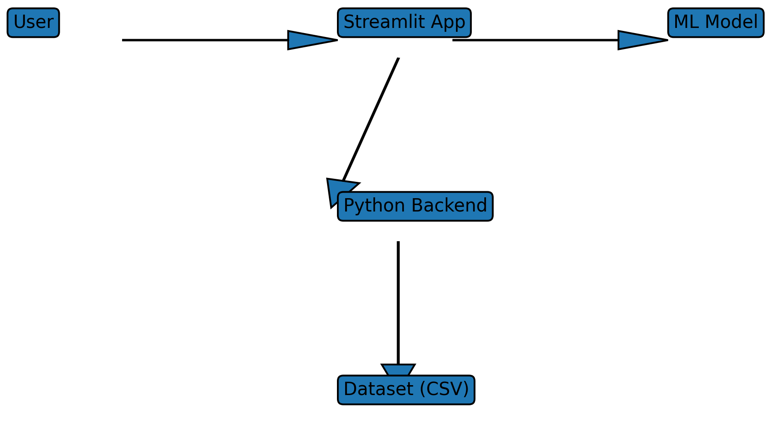

Technology Stack
Component | Description | Technology
Frontend | User Interface | Streamlit
Backend | Application Logic | Python
Machine Learning | Prediction Model | Scikit-learn
Dataset | Training Data | CSV Dataset

